

**CAPSTONE PROJECT 1**

**PROPOSAL DOCUMENT**

**LinguaSnap for Travelers**

**CODE:** PROPOSAL_v1.3

**Date :** 16 March 2023

**Submitted by**

**Dat, Nguyen Thanh**

**Truong, Vu Dinh**

**Long, Pham Ba Hoang**

**Kha, Nguyen Ngoc**

**Approved by Nguyen Duc Man**

**Capstone Project 1- Mentor:**

Name Signature Date

**INTERNATIONAL SCHOOL OF DUY TAN UNIVERSITY**

**PROJECT INFORMATION**

|  |  |  |  |
| --- | --- | --- | --- |
| **Project acronym** | LiS | | |
| **Project title** | LinguaSnap for Travelers | | |
| **Start date** | 25 – February – 2023 | **End Date** | 31 – May – 2023 |
| **Lead institution** | International School, Duy Tan University | | |
| **Project mentor** | Nguyen Duc Man  Email: mannd@duytan.edu.vn  Phone: +84 904 235 945 | | |
| **Partner organization** | Duy Tan University | | |
| **Scrum Master** | Dat, Nguyen Thanh | ntdat1232001@gmail.com | 0972530969 |
| **Product owner** | Truong ,Vu Dinh | jonnyvu2210@gmail.com | 0905223611 |
| **Team members** | Kha, Nguyen Ngoc | winkha14567@gmail.com | 0945721427 |
| Long, Pham Ba Hoang | longphambahoang@gmail.com | 0793310221 |

|  |  |  |  |
| --- | --- | --- | --- |
| Document History | | | |
| **Version** | **Author** | **Date** | **Comments** |
| V1.1 | All members | 5 March 2023 | Draft for comment |
| V1.2 | Trường | 15 March 2023 | Draft for comment |
| V1.3 | Trường | 16 March 2023 | Official |

**Table of Contents**

1. Introduction 4

1.1 Purpose 4

1.2 Scope 4

2. Project Overview 4

2.1 Project definition 4

2.2 Business needs/ User needs 4

2.3 Prior Art: 5

2.4 Proposed Solution 6

2.4.1 Project goal 7

2.4.2 Introduction ML (Machine Translated) Kit 7

2.4.3 Introduction Google Translation API 7

2.4.4 Introduction Firebase Realtime Database 7

2.4.5 System overview 8

2.4.5.1 System context 8

2.4.5.2 System context description 9

2.4.6 Technical Constrains 9

3 Master Plan 9

3.1 Scrum Process 9

4 Organization Management 10

4.1 Human Resource 10

4.2 Master plan 11

5 Cost Estimation 11

6 Project Constraints 12

7 Conclusion 14

8 References 14

9 Attachment: DESCRIPTION OF PRODUCT REQUIREMENTS FORM 15

9.1 Short description of product ideas (less than 7 statements) 15

9.2 Requirements 15

# 

# Introduction

## Purpose

The purpose of the proposal is to:

* Define the business need and problem in detail.
* Provide solutions for business needs and show the overview of system architecture.
* Provide overview about resources, schedule, solution and budget for the project.

## Scope

This document provides an overview of project will be developed. It includes the description of business need, the proposed solution, financial forecast and some constraints that involved in the project.

The document provides a comprehensive master plan for each phase of software development based on the processes that have been selected.

This document is made for senior management to put forward a proposal.

# Project Overview

## Project definition

To build an application with full features for users to translate and search after translation. Users can translate from image scan to search by image or search for content after detecting the language from the image. Users can review their usage history content.

## Business needs/ User needs

Trying to grasp and understand the universal nuances of many languages is a whole different game. Until now, the only way to translate was for 'interpreters' to study multiple languages and try to translate and bridge language boundaries for different purposes.

When traveling or studying, people needs an application that can translate and search in the most accurate way, helping people to quickly solve the necessary problem.

Learning is the nature of each of us. The current trend of users needs technologies that make it easy to use and optimize in translation, search as well as being able to store the necessary things during use.

To resolve the above objectives, based on the knowledge of students about to graduate and enthusiastic guidance of instructors, the team will create an application that can translate from other languages and search based on the results after translation. The application allows scanning from images to text to find information, or search right from images to help us select text, search for favorite content in a smart way....

No need for users to finish copying and searching on other websites, this will cause time and errors in the process of copying and uploading to other websites for search

## Prior Art:

Up until now, there have been a few common apps that provide some of those features, but they are not all together, which means users have to download several apps to use those features.

Example:

* Google Translate
* Google Lens
* Microsoft Lens

|  |  |  |  |
| --- | --- | --- | --- |
|  | **Google Lens** | **Microsoft Lens** | **Google Translate** |
| Main Function | Image recognition and providing related information | Document scanning and converting to editable PDF or text | Text translation and providing related information |
| Language Support | Multiple languages | Multiple languages | Multiple languages |
| Integration | Integrated within Google Photos and Google Assistant | Integrated within Microsoft Office and OneDrive | Integrated within Google Translate and other Google apps |
| Performance | Good at recognizing objects, locations, products | Good at document scanning and text recognition | Good at text translation and providing related information |
| Accuracy | High accuracy in image recognition | Good accuracy in document scanning and text recognition | Good accuracy in text translation |
| Special Features | Product search, plant and animal recognition, location information | Converting documents to editable text | Text translation via image or text input |

## Proposed Solution

Our team decided to build a “LinguaSnap” app with convenient and fully functioning features by integrating Google Translation API, Machine Translated Kit . With these features, the users will have an easier time traveling or learning. Our project is built based on the requirements and our team come up with solutions and project implementation:

* Application is a mobile application, running on android platform.
* This software is design for users whoa are tourists, students …and other people who want an app that can help them translate.

## Project goal

The goal of project is to build the “LinguaSnap” app with more functions that meet customer needs within budget and schedule successfully:

* Translate the texts that the user wish to know with different approaches with different languages.
* Help the user find the location of a picture on the internet.
* Synchronize user accounts for persistent data.
* User guide.
  + 1. **Introduction ML (Machine Translated) Kit**

ML Kit is a mobile SDK that brings Google's machine learning expertise to Android and iOS apps in a powerful yet easy-to-use package. ML Kit comes with a set of ready-to-use APIs for common mobile use cases: recognizing text, detecting faces, identifying landmarks, scanning barcodes, labeling images, and identifying the language of text. ML Kit’s selection of APIs run on-device or in the cloud. Our on-device APIs can process your data quickly and work even when there’s no network connection. Our cloud-based APIs, on the other hand, leverage the power of Google Cloud's machine learning technology to give you an even higher level of accuracy.

## Introduction Google Translation API

The Google Translation API is a cloud-based service provided by Google that allows developers to integrate machine translation functionality into their applications. The API provides a simple, programmatic interface for translating text from one language to another using Google's machine learning algorithms.

Developers can use the Google Translation API to build applications that can automatically translate text on the fly, such as chatbots or mobile apps. The API supports over 100 languages and can handle both text and speech input.

## Introduction Firebase Realtime Database

The Firebase Realtime Database lets you build rich, collaborative applications by allowing secure access to the database directly from client-side code. Data is persisted locally, and even while offline, realtime events continue to fire, giving the end user a responsive experience. When the device regains connection, the Realtime Database synchronizes the local data changes with the remote updates that occurred while the client was offline, merging any conflicts automatically.

The Realtime Database provides a flexible, expression-based rules language, called Firebase Realtime Database Security Rules, to define how your data should be

structured and when data can be read from or written to. When integrated with Firebase Authentication, developers can define who has access to what data, and how they can access it.

The Realtime Database is a NoSQL database and as such has different optimizations and functionality compared to a relational database. The Realtime Database API is designed to only allow operations that can be executed quickly. This enables you to build a great realtime experience that can serve millions of users without compromising on responsiveness.

## System overview

## System context

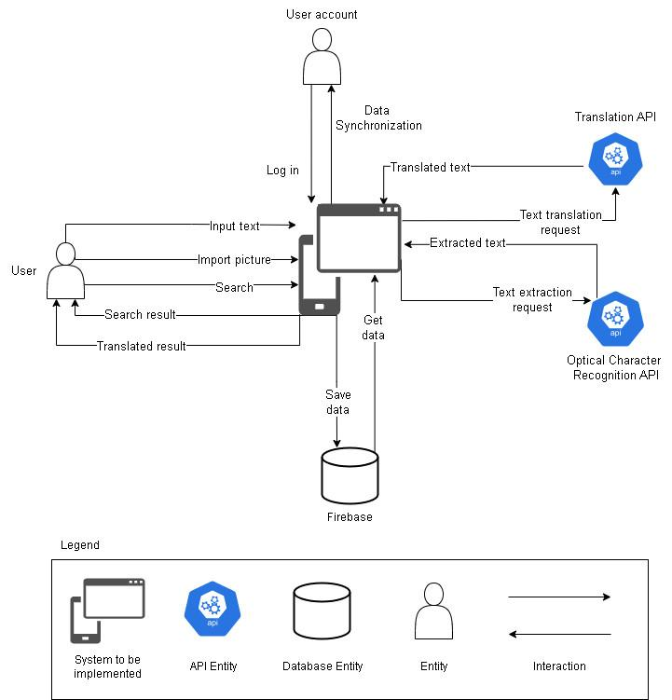

**Figure 1: System context overview**

## System context description

The application will provide 3 main features:

* Translate the texts users wish to know by different forms of approaches such as writing, speaking, pictures.
* Find the location of the pictures they import on the Internet.
* Store the data of the user for synchronization and other functions.

## Technical Constrains

**Technicals for Buiding Project**

* Language: Java
* Operating system: Microsoft Windows
* Develop tool: Android Studio
* Database Management System: Firebase

**Environment**

* Tool: Android Studio
* Operation systems: Microsoft Windows

**Bussiness Constraints**

* Resource: 4 people.
* Budget: 3000$.
* Time: The project must be completed within 3 months.

# Master Plan

## Scrum Process

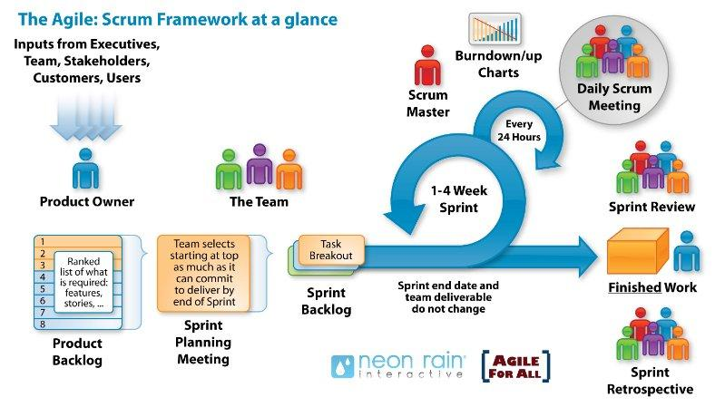

**Figure 2: General SCRUM Process**

* Scrum is an iterative and incremental agile software development framework for managing software projects and product or application development.
* Scrum focuses on project management institutions where it is difficult to plan ahead.
* Mechanisms of empirical process control, where feedback loops that constitute the core management technique are used as opposed to traditional command-and-control management.
* Its approach to planning and managing projects is by bringing decision-making authority to the level of operation properties and certainties.

# Organization Management

## Human Resource

* Team’s Information

|  |  |  |  |
| --- | --- | --- | --- |
| **Full Name** | **Phone** | **Email** | **Position** |
| Msc. Nguyen Duc Man |  | mannd@dtu.duytan.edu | Mentor |
| Nguyen Thanh Dat | 0972530969 | ntdat1232001@gmail.com | Team Leader |
| Nguyen Ngoc Kha | 0945721427 | winkha14567@gmail.com | Team Member |
| Pham Ba Hoang Long | 0793310221 | longphambahoang@gmail.com | Team Member |
| Vu Dinh Truong | 0905223611 | jonnyvu2210@gmail.com | Team Member |

## Master plan

|  |  |  |  |  |
| --- | --- | --- | --- | --- |
| NO | Task Name | Duration | Start | Finish |
| 1 | Initial | 4 | 25/02/2023 | 03/03/2023 |
|  | Gathering Requirement | 3 | 27/02/2023 | 02/03/2023 |
|  | Create Proposal Document | 1 | 03/03/2023 | 03/03/2023 |
| 2 | Start Up | 3 | 06/03/2023 | 08/03/2023 |
|  | Create documents for project | 3 | 06/03/2023 | 08/03/2023 |
| 3 | Development | 56 | 09/03/2023 | 26/05/2023 |
|  | Sprint 1 | 21 | 09/03/2023 | 07/04/2023 |
|  | Sprint 2 | 21 | 08/04/2023 | 09/05/2023 |
|  | Sprint 3 | 14 | 10/05/2023 | 30/05/2023 |
| 4 | Project’s Retrospective Meeting and final release | 1 | 31/05/2023 | 31/05/2023 |

# Cost Estimation

The following outlines the cost to complete all the identified components for the project.

|  |  |  |  |
| --- | --- | --- | --- |
| **No.** | **Phase** | **Milestone** | **Cost( 2 hours/day)**  **USD** |
| 1.  2. | Start-up  Development | STU | $100 |
| SPR1 | $600 |
| SPR2 | $600 |
| SPR3 | $600 |
| 3. | Other costs | OTH | $300 |
| 4. | Project’s Meeting | PM | $20 |
| 5. | Final Release | FR | $28 |
| 6. | **Total** | | **$2.248** |

# Project Constraints

|  |  |  |
| --- | --- | --- |
| **Constraint** | **Constraints Description** | **Guidelines for Acceptance** |
| **Information sharing** | N/a | N/a |
| **Ethical** | Translate apps can sometimes produce inaccurate translations, which can result in misunderstandings or miscommunications. It is essential to ensure that the translations provided by the app are reliable and accurate, especially when it comes to critical or sensitive information.  Translate apps can pose a risk to confidentiality if they are used to translate sensitive or confidential information. It is essential to ensure that the app's privacy policy and terms of use protect the confidentiality and security of the data being translated. | + Absolute security for the user's personal data in the application, not using with unauthorized purposes, disrespecting user data.  + Build clean applications with safe content, do not contain offensive, cultural and unethical images  + Pay special attention to gender, religion, ethnicity, and age issues. |
| **Intellectual property rights issues** | N/a | N/a |
| **Economic and E-Commerce** | This project is under monitoring by the college campus environment, so, this is a non-profit project | + Information security, preventing fake information and untrustworthy information. Provide sufficient information and support state management agencies in investigating business acts in violation of the law using their application. |
| **Trade promotion activities** | N/a | N/a |
| **Advertising activities** | N/a | N/a |
| **Google Play Store Policies** | N/a | N/a |
| **Sustainability** | A quality software product must cover issues from future development to maintenance and expansion. To achieve sustainability and long-term survival in the market it must achieve sustainability from the investment of resources, infrastructure, material, equipment, maintenance, ... This attribute determines the viability of a product and the possibility of its future development. | + The system operates 24/7 with 99.99% uptime  + Reuse existing services with low risk and high reliability.  + Periodically back up data to ensure data safety, avoid data loss cases  + Test achieves a minimum error coverage rate of 80%.  + Update new technology trends to keep up with the age and increase competitiveness |

# Conclusion

Traveling to a new country can be an exciting and enriching experience, but it can also be challenging if you don't speak the local language. Ordering food, asking for directions, or even reading street signs can be difficult when you don't understand the language. With the help of this app, you can navigate language barriers with ease and enjoy all that your destination has to offer. From snapping a picture of a menu to translating a conversation in real-time, this app provides the convenience and accessibility that travelers need.

Our system will integrate with Translation API for translating text, Image Search API for searching similar result and OCR API for extracting text from image. The project team will develop this system within 12 weeks with a budget of 3000 dollars for 4 members. We ensure compliance with schedule, budget and on-time product delivery. We are determined to together with consensus, solidarity, research solutions to overcome challenges and manage progress to bring the project to success.

# References

|  |  |  |
| --- | --- | --- |
| **No.** | **References** | **Document Information** |
| 1 | Scrum Model | <https://en.wikipedia.org/wiki/Scrum_(software_development)> |
| <https://www.atlassian.com/agile/scrum> |
| <https://www.digite.com/agile/scrum-methodology/> |
| [https://docs.microsoft.com/en-us/azure/devops/boards/sprints/b](https://docs.microsoft.com/en-us/azure/devops/boards/sprints/best-practices-scrum?view=azure-devops) [est-practices-scrum?view=azure-devops](https://docs.microsoft.com/en-us/azure/devops/boards/sprints/best-practices-scrum?view=azure-devops) |
| <https://www.scrum.org/resources/scrum-guide> |
| 2 | Technical | https://api-ninjas.com/api/imagetotext |
| https://ocr.space/ocrapi |
| https://cloud.google.com/translate |
| https://github.com/matheuss/google-translate-api |
| 3. | Software Engineering Standards | [https://www.nws.noaa.gov/oh/hrl/developers_docs/General_So](https://www.nws.noaa.gov/oh/hrl/developers_docs/General_Software_Standards.pdf) [ftware_Standards.pdf](https://www.nws.noaa.gov/oh/hrl/developers_docs/General_Software_Standards.pdf) |
| <https://standards.ieee.org/standard/12208-2017.html> |
| <https://sw-eng.larc.nasa.gov/> |

# Attachment: DESCRIPTION OF PRODUCT REQUIREMENTS FORM

#### DESCRIPTION OF PRODUCT REQUIREMENTS

Group: C1SE.05

Project: Traveling Companion

Date: 06 Mar 2023

## Short description of product ideas (less than 7 statements)

|  |
| --- |
| Today's modern life, the quality of human life has improved in every aspect. As a result, the need for entertainment, such as travel, has grown stronger than ever. However, traveling to another country is not that simple. Language barriers and lack of knowledge have proved to be significant problems that can ruin your vacation. Nowadays, everyone owns a smartphone, so we came up with an idea that can help you search an entire picture, translate and extract the words from the image, and much more.  Translation can be done manually by a human translator, or through the use of machine translation software, which employs algorithms and artificial intelligence to automatically translate text. Translation is an important tool for communication, enabling people from different linguistic and cultural backgrounds to understand and interact with each other. |

1. **Requirements**

|  |  |
| --- | --- |
| High-level Functional Requirements | 1. Input: The system should be able to receive input in the form of text, speech or other data format from the user. |
| 2. Source Language Identification: The system should be able to automatically identify the language of the input text. |
| 3. Translation: The system should be able to translate the input text into the desired target language. |
| 4. Output: The system should be able to output the translated text in the desired format, such as text, speech or other data format. |
| 5. Quality Assessment: The system should be able to assess the quality of the translation based on various parameters, such as accuracy, fluency, and naturalness. |
| 6. Customization: The system should allow for customization based on user needs, such as specialized vocabularies or industry-specific terminology. |
| 7. Integration: The system should be able to integrate with other software or systems, such as chatbots or content management systems. |
| 8. Security: The system should ensure the security of the input and output data, and protect user privacy. |
| 9. Performance: The system should be able to provide accurate and efficient translations within a reasonable amount of time. |
|  | 10. User Interface: The system should have a user-friendly interface that is easy to use and understand, and should provide feedback to the user throughout the translation process. |

|  |  |
| --- | --- |
| Quality Attributes Requirements  (example related to issues: Ease  Use, Easy to Like, Easy to Learn, Easy to Understand, Easy to Buy / Yes, ...) | 1. Ease Use |
| 2. Easy to Understand |
| 3. |
| 4. |
| 5. |

|  |  |
| --- | --- |
| Operation Requirements  (related to issues: Speed, Accuracy, Performance, Stability, Load Resistance, Scalability, Safety, ...) | 1. Accuracy |
| 2. Stability |
| 3. Scalability |
| 4. |
| 5. |

|  |  |
| --- | --- |
| Environment & Operation Requirements  (related to issues: physical impacts on the environment, interact with relevant or existing systems, conditions for product commercialization, ...) | 1. Environmental factors do not affect the system |
| 2. |
| 3. |
| 4. |
| 5. |

|  |  |
| --- | --- |
| Requirements for Maintenance & Support | 1. Periodical maintenance once every 3 months |
| 2. |
| 3. |
| 4. |
| 5. |

|  |  |
| --- | --- |
| Security/ Safety Requirements  (related to issues: conditions of use / access to products, personal freedom, inspection, ...) | 1. User's personal information is kept confidential. |
| 2. |
| 3. |
| 4. |
| 5. |

|  |  |
| --- | --- |
| Culture Requirements | 1. Slang and Colloquialisms: The system should be able to accurately translate slang and colloquialisms in a way that reflects their cultural context. |
| 2. Political Correctness: The system should be designed to avoid language that may be considered offensive or inappropriate in certain cultural contexts. |
| 3. User Feedback: The system should allow users to provide feedback on translations to help improve the accuracy and appropriateness of future translations. |
| 4. |
| 5. |

|  |  |  |
| --- | --- | --- |
| Evaluate the complexity of engineering problems |  | 1. Involving wide-ranging or conflicting technical issues |
|  | 2. Having no obvious solution |
|  | 3. Addressing problems not encompassed by current standards and codes |
|  | 4. Involving diverse groups of stakeholders |
| ✔ | 5. Including many component parts or sub-problems |
|  | 6. Involving multiple disciplines |
|  | 7. Having significant consequences in a range of contexts |

|  |  |  |
| --- | --- | --- |
| Standard requirements | ✔ | 1. Code standard. (GNU, Oracle standard for Java, ..,) |
|  | 2. Design standard. (design patterns, object-oriented analysis and design,…). |
|  | 3. IEEE (1058, 1540, 830, 1016, 829, 1012, 1008) |
|  | 4. ISO/IEC/IEEE 12207:2017 (TCVN 10539:2014); ISO/IEC 25051:2006(TCVN 10540:2014); |
|  | 5. Other standards. (related to specific topics) |